**Experiment no- 07**

Name: Suraj P. Patil

Roll No: 3034

URN: 20131086

Class: TY(A)

Batch: T-2

**Title:**

*Draw Package Diagram.*

A package diagram is a type of structural diagram that shows how the different packages in a system are organized and how they depend on one another.

A package is a container for organizing model elements such as classes, interfaces, components, and other packages. Package diagrams provide a way to visualize the organization of a large system by showing the hierarchy of packages and their relationships.

A package diagram consists of packages, which are represented as rectangles with a name and a list of contained elements. The dependencies between packages are represented as arrows pointing from the dependent package to the independent package. The arrows can indicate different types of relationships such as "uses," "includes," "extends," and "generalizes."

Package diagrams are useful for showing the overall structure of a system and for communicating the organization of the system to stakeholders. They are often used in software development to help manage large code bases and to improve the overall architecture of a system.

**What is package?**

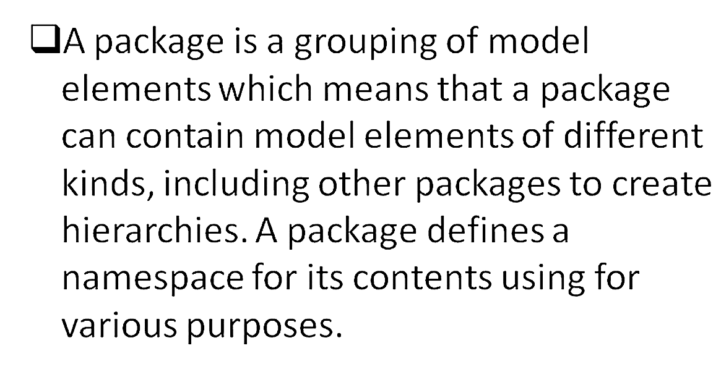

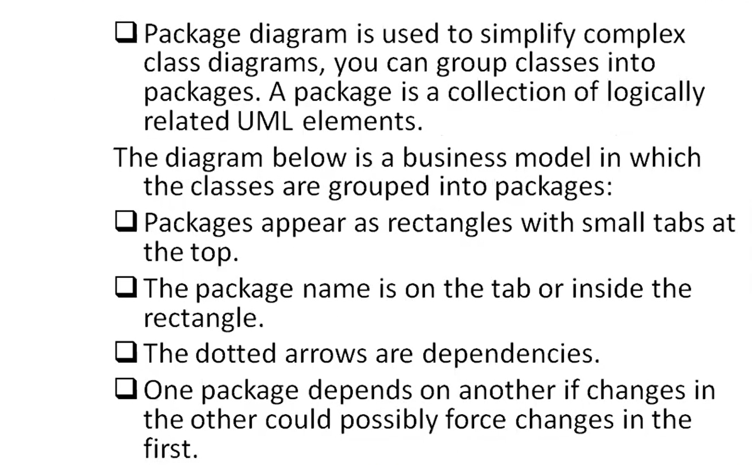

**Key elements of package:**

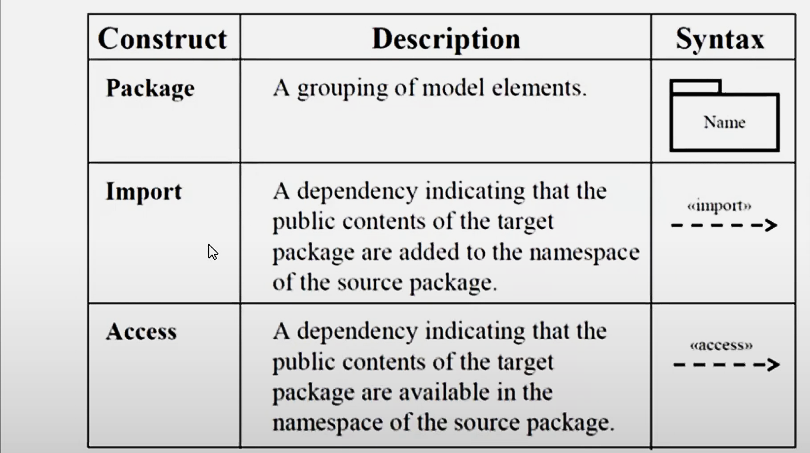

**Below is thepackage diagram for YouTube.**

